**LAB EXERCISE 4**

The purpose of this lab is to create an interface to insert, update and delete a location of a Class. Create a HTML and CSS using the provider file in BootStrap only. Understand the format of the class about table preview. Using this link to test the table preview.

Objective

1. To use session
2. To use modular programming
3. To use Function
4. To implement the Insert, update and delete in a tables

<https://www.w3schools.com/bootstrap/bootstrap_tables.asp>

You are given a table schema for table name location as below.

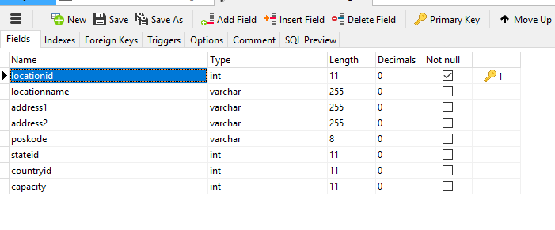

**Example script SQL Script**

Use your phpmyadmin to deploy this SQL table. The script is also available in the google classroom.

CREATE TABLE `location` (

`locationid` int(11) NOT NULL,

`locationname` varchar(255) DEFAULT NULL,

`address1` varchar(255) DEFAULT NULL,

`address2` varchar(255) DEFAULT NULL,

`poskode` varchar(8) DEFAULT NULL,

`stateid` int(11) DEFAULT NULL,

`countryid` int(11) DEFAULT NULL,

`capacity` int(11) DEFAULT NULL,

PRIMARY KEY (`locationid`),

KEY `countryid` (`countryid`) USING BTREE,

CONSTRAINT `location_ibfk_1` FOREIGN KEY (`countryid`) REFERENCES `countries` (`id`) ON DELETE CASCADE ON UPDATE CASCADE

) ENGINE=InnoDB DEFAULT CHARSET=latin1;

-- ----------------------------

-- Records of location

-- ----------------------------

INSERT INTO `location` VALUES ('0', 'UIA ITD LAB', null, null, null, null, null, null);

INSERT INTO `location` VALUES ('1', 'IWORLD', 'Megan Avenu 1', 'Jln Yap Kwan Seng', '50450', '10', '132', '20');

INSERT INTO `location` VALUES ('2', 'KTMB', 'JLN SULTAN IBRAHIM', 'KUALA LUMPUR', '54500', '10', '132', '20');

INSERT INTO `location` VALUES ('3', 'LAB 1 TECHNO RADA', 'Unit 3, First Floor, Block E', 'Bangunan Dato Paduka Lim Seng Kok Spg 624, Kg. Madewa, Jalan Tutong\r\n', 'BF1120', '101', '32', '12');

INSERT INTO `location` VALUES ('4', 'LAB 2 TECHNO RADA', 'Unit 3, First Floor, Block E', 'Bangunan Dato Paduka Lim Seng Kok Spg 624, Kg. Madewa, Jalan Tutong\r\n', 'BF1120', '101', '32', '6');

INSERT INTO `location` VALUES ('5', 'Info Trek', 'PJ', 'Bangunan Dato Paduka Lim Seng Kok Spg 624, Kg. Madewa, Jalan Tutong\r\n', 'BF1120', '101', '32', '6');

After deploying the SQL, verify the table accessible and check you root password in the PHPMyAdmin.

**STEP 1**

Analyst the function provided and only use the function available to create all the function in your program.

1. Complete Lab 3 Login first
2. Create a webpage for mainpage or a link into the admin.php . This link will be link to a webpage call location.php.
3. Location.php Design is as follow.

Click Here to insert new Records

|  |  |  |  |
| --- | --- | --- | --- |
| Name | Company | Country | Delete |
| [Xxx](updatelocation,php?locationid=xx) | Yyy | Malaysia |  |

Link example for Update

**Requirements**

Below are the requirements for file links

Update URL

*updatelocation.php?locationid=xx*

Insert URL

*Insertlocation.php*

Table must be using the bootstrap and it is mobile ready. You may use the bootstrap buttons.